***FARM BUSINESS 2***

***FOR UNITY ANDROID MANUAL***

***Android build***

***Open Projects and choose File Menu, select “Build Settings...” (shortcut key: Ctrl + Shilf + B)***

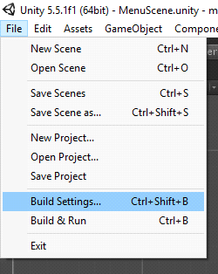

***Press Player Settings... button on Build Settings dialog to open PlayerSettings on Inspector windows***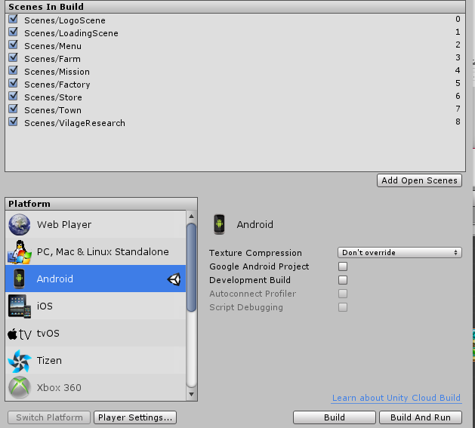

***On PlayerSettings window, fill/change information if need, press Browse Keystore to add your keystore, fill password, choose Alias & fill password for that alias***

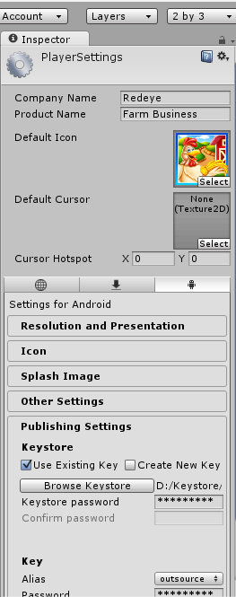

***After all build settings is set, press Build in Build Settings window and enter file name in Save dialog to start building***

***Waiting for building process complete to receive an apk file, this file is ready to publish***

***Change the game graphics & sounds:***

***All graphics are stored in Images folder, replace images by new appropriate one.***

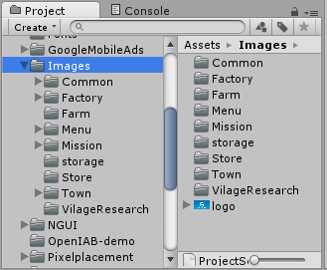

***All sounds are stored in Audio folder, replace sounds by new appropriate one.***

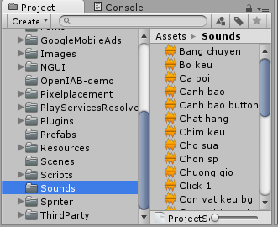

***Change advertisement id***

***Adverisement ids are stored in Scripts/GoogleAdmob.cs script file.***

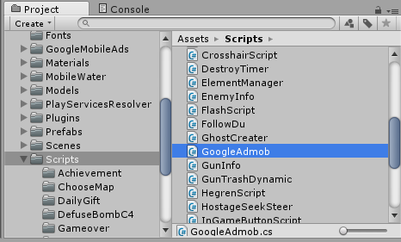

**Open AdmobControl.cs to change the Banner ID and Interstitial ID**

